10. Technical Requirements
The CrisisClarity system uses a modern full-stack architecture combining mobile, backend, AI, database, and DevOps technologies to ensure scalable and real-time disaster communication.
- Technologies Used
The frontend is built with Flutter for cross-platform mobile and web applications, using Riverpod/Provider for state management. The backend uses Python FastAPI for fast and asynchronous API handling.
Firebase Firestore is used for real-time data storage, along with Firebase Authentication and FCM for security and notifications. AI features are powered by the Groq API (LLaMA 3.3) for translation, summarization, and chatbot responses.
A multi-agent AI system (Data Collection, Verification, Scoring, Classification) validates alerts and assigns trust scores. RSS feeds (TOI, NDTV, GDACS, ReliefWeb) are used for real-time news verification.



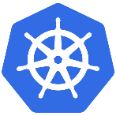

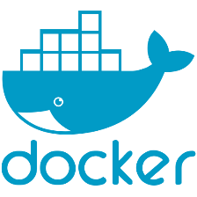


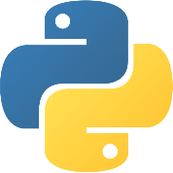
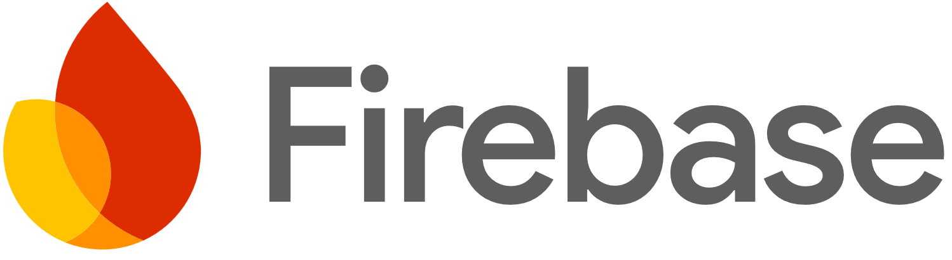


A Telegram Bot enables alert delivery and feedback collection. Docker, Docker Compose, and Kubernetes (Minikube) support deployment and scaling, while GitHub Actions handles CI/CD and Prometheus wi th G rafana provides monitoring.

- Technical Architecture Diagram
The Technical Architecture Diagram figure 10.1 illustrates the complete workflow of the system from the user interface to backend processing and external integrations. The process starts with the Flutter frontend, where users interact with alert screens and an AI chatbot with voice input/output. User actions such as viewing alerts, asking queries, or giving feedback are sent as HTTP API requests to the FastAPI backend.
The backend acts as the core processing unit and manages the multi-agent AI pipeline. The Data Collection Agent gathers data from Firebase and RSS feeds, the Verification Agent cross-checks information, the Scoring Agent assigns a trust score, and the Classification Agent generates the final verified output. The system integrates external services such as the Groq API for AI processing, Telegram Bot for alert delivery, and RSS feeds for real-time updates. Data is stored in Firebase Firestore, with Redis used for caching. A feedback loop allows users to respond (“Understood / Not Understood”), enabling continuous improvement through real-time analytics.

- DevOps Architecture Diagram
The DevOps Architecture Diagram figure 10.2 explains how the system is deployed and maintained in a scalable environment. The backend services are containerized using Docker with secure configurations and health checks. Docker Compose is used to manage multiple services like FastAPI, Redis, and Nginx for smooth development and testing.
Kubernetes (Minikube) is used for container orchestration, ensuring scalability, load balancing, and high availability. A CI/CD pipeline using GitHub Actions automates testing, security checks, building Docker images, and deployment, enabling continuous delivery. Monitoring tools like Prometheus and Grafana track system performance and resource usage, helping in early issue detection and system optimization.

